Software Requirements Specification

for

Cafeteria Ordering System, Release 1.0

Version 1.0 approved

Prepared by Khadija yousuf, Aiman Mohsin, Hareem Zubair

Process Impact

December 21, 2016

Table of Contents

Table of Contents ii

1. Introduction 3

1.1 Purpose 3

1.2 Project Scope and Product Features 3

2. Overall Description 3

2.1 Product Perspective 3

2.2 User Classes and Characteristics 3

2.3 Operating Environment 4

2.4 Design and Implementation Constraints 4

3. System Features 4

3.1 Order Meals 4

4. External Interface Requirements 6

4.1 User Interfaces 6

4.2 Software Interfaces 6

4.3 Communications Interfaces 6

5. Other Nonfunctional Requirements 6

5.1 Performance Requirements 6

5.2 Safety Requirements 7

5.3 Security Requirements 7

Appendix A: Data Dictionary and Data Model 7

Appendix B: Graphical User Interaction Models 9

# Introduction

## Purpose

This SRS describes the software functional and nonfunctional requirements for release 1.0 of the Cafeteria Ordering System (COS). This document is intended to be used by the members of the project team that will implement and verify the correct functioning of the system. Unless otherwise noted, all requirements specified here are high priority and committed for release 1.0.

## Project Scope and Product Features

The Cafeteria Ordering System will permit Process Impact employees to order meals from the company cafeteria on-line to be delivered to specified campus locations. A detailed project description is available in the *Cafeteria Ordering System Vision and Scope Document* [1]. The section in that document titled “Scope of Initial and Subsequent Releases” lists the features that are scheduled for full or partial implementation in this release.

# Overall Description

## Product Perspective

The Cafeteria Ordering System is a new system that replaces the current manual and telephone processes for ordering and picking up lunches in the Process Impact cafeteria. The context diagram in Figure 1 illustrates the external entities and system interfaces for release 1.0. The system is expected to evolve over several releases, ultimately connecting to the Internet ordering services for several local restaurants and to credit and debit card authorization services.

## User Classes and Characteristics

|  |  |
| --- | --- |
| Patron (favored) | A Patron is a Process Impact employee at the corporate campus in a XYZ Company, Pakistan, who wishes to order meals to be delivered from the company cafeteria. There are about 600 potential Patrons, of which an estimated 400 are expected to use the Cafeteria Ordering System an average of 4 times per week each (source: current cafeteria usage data). Patrons will sometimes order multiple meals for group events or guests. An estimated 90 percent of orders will be placed using the corporate Intranet, with 10 percent of orders being placed from home. All Patrons have Intranet access from their offices. Some Patrons will wish to set up meal subscriptions, either to have the same meal to be delivered every day or to have the day’s meal special delivered automatically. A Patron must be able to override a subscription for a specific day. |
| Cafeteria Staff | The Process Impact cafeteria currently employs about 20 Cafeteria Staff, who will receive orders from the Cafeteria Ordering System, prepare meals, package them for delivery, print delivery instructions, and request delivery. Most of the Cafeteria Staff will need to be trained in the use of the computer, and the Cafeteria Ordering System. |
| Menu Manager | The Menu Manager is a cafeteria employee, perhaps the cafeteria manager, who is responsible for establishing and maintaining daily menus of the food items available from the cafeteria and the times of day that each item is available. Some menu items may not be available for delivery. The Menu Manager will also define the cafeteria’s daily specials. The Menu Manager will need to edit the menus periodically to reflect planned food items that are not available or price changes. |
| Meal Deliverer | As the Cafeteria Staff prepare orders for delivery, they will print delivery instructions and issue delivery requests to the Meal Deliverer, who is either another cafeteria employee or a contractor. The Meal Deliverer will pick up the food and delivery instructions for each meal and deliver it to the Patron. The Meal Deliverers’ primary interactions with the system will be to reprint the delivery instructions on occasion and to confirm that a meal was (or was not) delivered. |

## Operating Environment

OE-1: The Cafeteria Ordering System shall operate with the desktop application Cafeteria Ordering System Version 1.0 only.

## Assumptions and Dependencies

AS-1: The cafeteria is open for breakfast, lunch, and dinner every company business day in which employees are expected to be on site.

DE-1: The operation of the COS depends on changes being made in the Payroll System to accept payment requests for meals ordered with the COS.

DE-2: The operation of the COS depends on changes being made in the Cafeteria Inventory System to update the availability of food items as COS orders are accepted.

# System Features

## Order Meals

3.1.1 Description and Priority

A cafeteria Patron whose identity has been verified may order meals either to be delivered to a specified company location or to be picked up in the cafeteria. A Patron may cancel or change a meal order if it has not yet been prepared. Priority = High.

3.1.2 Stimulus/Response Sequences

Stimulus: Patron requests to place an order for one or more meals.

Response: System queries Patron for details of meal(s), payment, and delivery instructions.

Stimulus: Patron requests to clear and change a meal order.

Response: System clears order and allows user to make new meal order.

3.1.3 Functional Requirements

|  |
| --- |
| Order.Place: The system shall let a Patron who is logged into the Cafeteria Ordering System place an order for one or more meals.  Order.Place.Register: The system shall confirm that the Patron is registered to place an order.  Order.Place.Register.No If the Patron is not registered, the system shall give the Patron options to register now and continue placing an order, or to exit from the COS. |
| Order.Deliver.Select: The Patron shall specify whether the order is to be picked up or delivered.  Order.Deliver.Location: If the order is to be delivered, the Patron shall provide a valid delivery location. |
| Order.Menu.Available: The menu for the current date shall display only those food items for which at least one unit is available in the cafeteria’s inventory. |
| Order.Units.Multiple: The system shall permit the user to order multiple identical meals, up to the fewest available units of any menu item in the order.  Order.Units.TooMany: If the Patron orders more units of a menu item than are presently in the cafeteria’s inventory, the system shall inform the Patron of the maximum number of units of that food item that he can order.  Order.Units.Change: If the available inventory cannot fulfill the number of units ordered, the Patron may change the number of units ordered, change the number of identical meals being ordered, or cancel the meal order. |
| Order.Confirm.Display: When the Patron indicates that he does not wish to order any more food items, the system shall display the food items ordered, the individual food item prices, and the payment amount, calculated per BR-12.  Order.Confirm.Prompt: The system shall prompt the Patron to confirm the meal order.  Order.Confirm.Not: If the Patron does not confirm the meal order, the Patron may either edit or cancel the order. |
| Order.Pay.Method: Cash only, either delivery or picked up.  Order.Pay.Deliver: See BR-11.  Order.Pay.Pickup: If the meal is to be picked up in the cafeteria, the system shall let the Patron choose to pay by payroll deduction or by paying cash at the time of pickup.  Order.Pay.Details: The system shall display the food items ordered, payment amount, payment method, and delivery instructions.  Order.Pay.Confirm: The Patron shall either confirm the order, request to edit the order, or request to cancel the order. |
| Order.Done: When the Patron has confirmed the order, the system shall do the following as a single transaction:  Order.Done.Menu: Update the menu for the current order’s order date to reflect any items that are now out of stock in the cafeteria inventory.  Order.Done.Times: Update the remaining available delivery times for the date of this order.  Order.Done.Patron: Show a receipt to the Patron with the meal order and meal payment information with save and print option. |
| Order.Previous.Period: The system shall permit the Patron to view any meals he has ordered as he can save and print customer receipt. |

# External Interface Requirements

## User Interfaces

UI-1: The Cafeteria Ordering System screen displays shall conform to the *Process Impact Internet Application User Interface Standard, Version 1.0*.

UI-2: The system shall provide a help link to explain how to use Cafeteria Ordering System.

UI-3: The Desktop application shall permit complete navigation and food item selection using the keyboard alone, in addition to using mouse and keyboard combinations.

## Software Interfaces

SI-1: Cafeteria Inventory System

SI-1.1: The COS shall poll the Cafeteria Inventory System to determine whether a requested food item is available.

SI-1.2: When the Cafeteria Inventory System notifies the COS that a specific food item is no longer available, the COS shall remove that food item from the menu for the current date.

## Communications Interfaces

CI-1: The Cafeteria Ordering System shall send a message to the Patron to confirm acceptance of an order, price, and delivery instructions.

CI-2: The Cafeteria Ordering System shall send a message to the Patron to report any problems with the meal order or delivery after the order is accepted.

# Other Nonfunctional Requirements

## Performance Requirements

PE-1: The system shall accommodate all users during the peak usage time window of 8:00am to 10:00am(Office timings) local time, with an estimated average session duration of 8 minutes.

PE-2: System shall be fully downloadable in no more than 10 seconds over a 40KBps modem connection.

PE-3: Responses to queries shall take no longer than 7 seconds to load onto the screen after the user submits the query.

PE-4: The system shall display confirmation messages to users within 4 seconds after the user submits information to the system.

## Security Requirements

SE-1: All network transactions that involve financial information or personally identifiable information shall be encrypted.

SE-2: Users shall be required to log in to the Cafeteria Ordering System for all operations except viewing a menu.

SE-3: Patrons shall log in according to the restricted computer system access policy.

SE-4: The system shall permit only cafeteria staff members who are on the list of authorized Menu Managers to create or edit menus.

SE-5: The system shall permit Patrons to Save and Print only their own placed orders, not orders placed by other Patrons.

## Software Quality Attributes

Availability-1: The Cafeteria Ordering System shall be available to users on the corporate Intranet and to dial-in users 99.9% of the time between 5:00am and midnight local time and 95% of the time between midnight and 5:00am local time.

Robustness-1: If the connection between the user and the system is broken prior to an order being either confirmed or canceled, the Cafeteria Ordering System shall enable the user to recover an incomplete order.

Appendix A: Data Dictionary and Data Model

|  |  |  |
| --- | --- | --- |
| delivery instruction | =  +  +  +  + | patron name  patron phone number  meal date  delivery location  delivery time window |
| delivery location | = | * building and room to which an ordered meal is to be delivered * |
| delivery time window | = | * 15-minute range during which an ordered meal is to be delivered; must begin and end on quarter-hour intervals * |
| employee Username | = | * Username of the employee who placed a meal order * |
| food item description | = | * text description of a food item on a menu; maximum 100 characters * |
| food item price | = | * pre-tax cost of a single unit of a menu food item, in rupees and paisas * |
| meal date | = | * the date the meal is to be delivered or picked up; format MM/DD/YYYY; default = current .* |
| meal order | =  +  +  +  +  + | meal order id  order date  1:m{ordered food item}  delivery instruction  meal order status |
| meal order number | = | * a unique, sequential integer that the system assigns to each accepted meal order; initial value is FI01 * |
| meal payment | =  +  + | payment amount  payment method i.e. cash  Cash on delivery/ Pickup |
| Menu | =  +  + | menu date  1:m{menu food item}  0:1{special} |
| menu date | = | * the date for which a specific menu of food items is available; format MM/DD/YYYY * |
| menu food item | =  + | food item description  food item price |
| order date | = | * the date on which a patron placed a meal order; format MM/DD/YYYY * |
| ordered food item | =  + | menu food item  quantity ordered |
| patron | =  +  +  +  + | patron name  employee ID  patron phone number  patron location |
| patron location | = | * building and room numbers of the employee who placed a meal order; 50 character alphanumeric * |
| patron name | = | * name of the employee who placed a meal order; 30 character alphanumeric * |
| patron phone number | = | * contact number of the employee who placed a meal order * |
| payment amount | = | * total price of an order in Rupees and paisas * |
| payment method | = | [ cash ] |
| quantity ordered | = | * the number of units of each food item that the Patron is ordering; default = 1; maximum = any number * |

# Appendix B: Graphical User Interface Model:

1. **Login Form:**

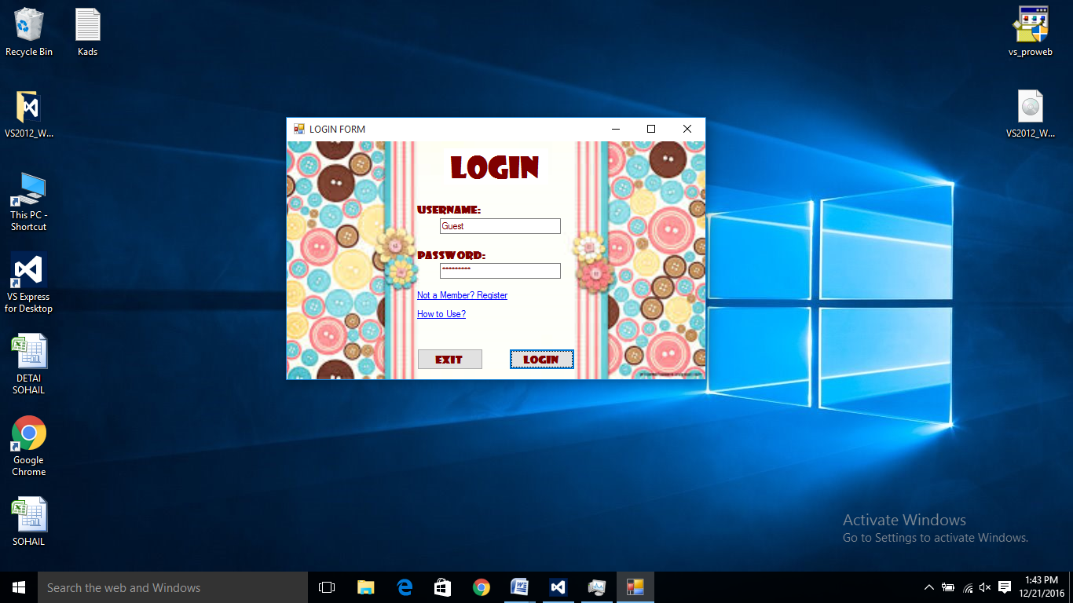

1. **Registration Form:**

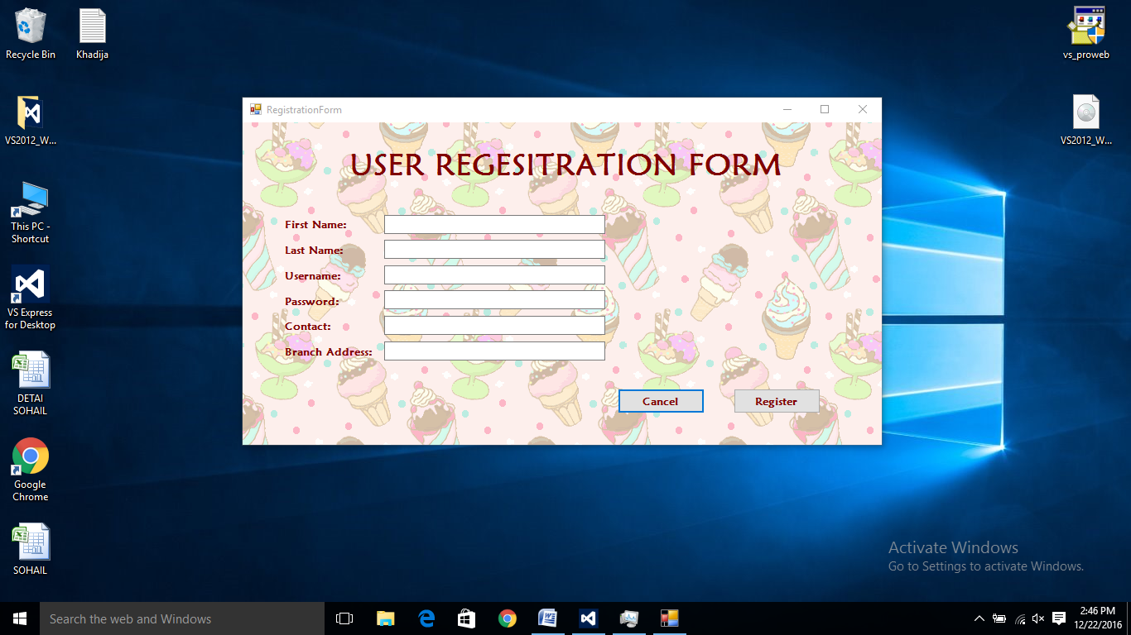

1. **Menu**

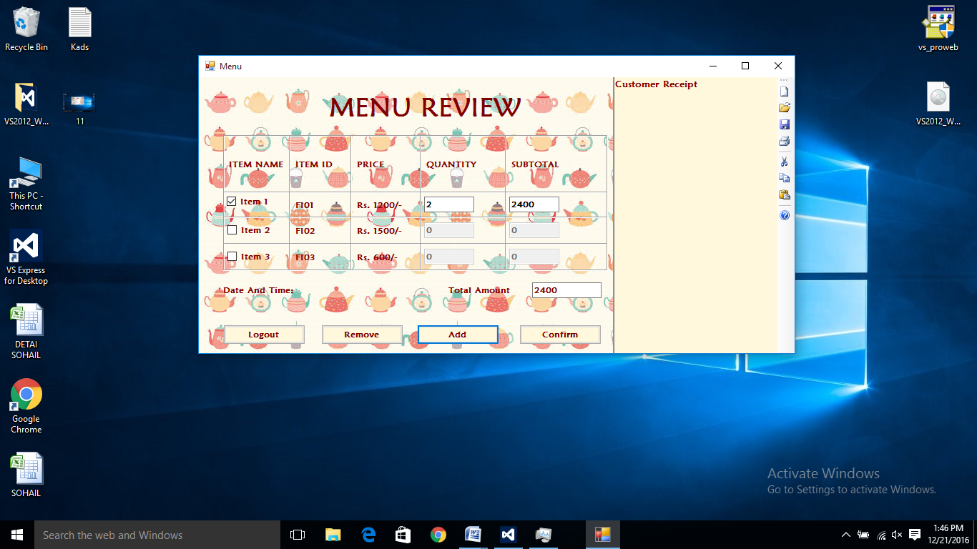

1. **Order Details**

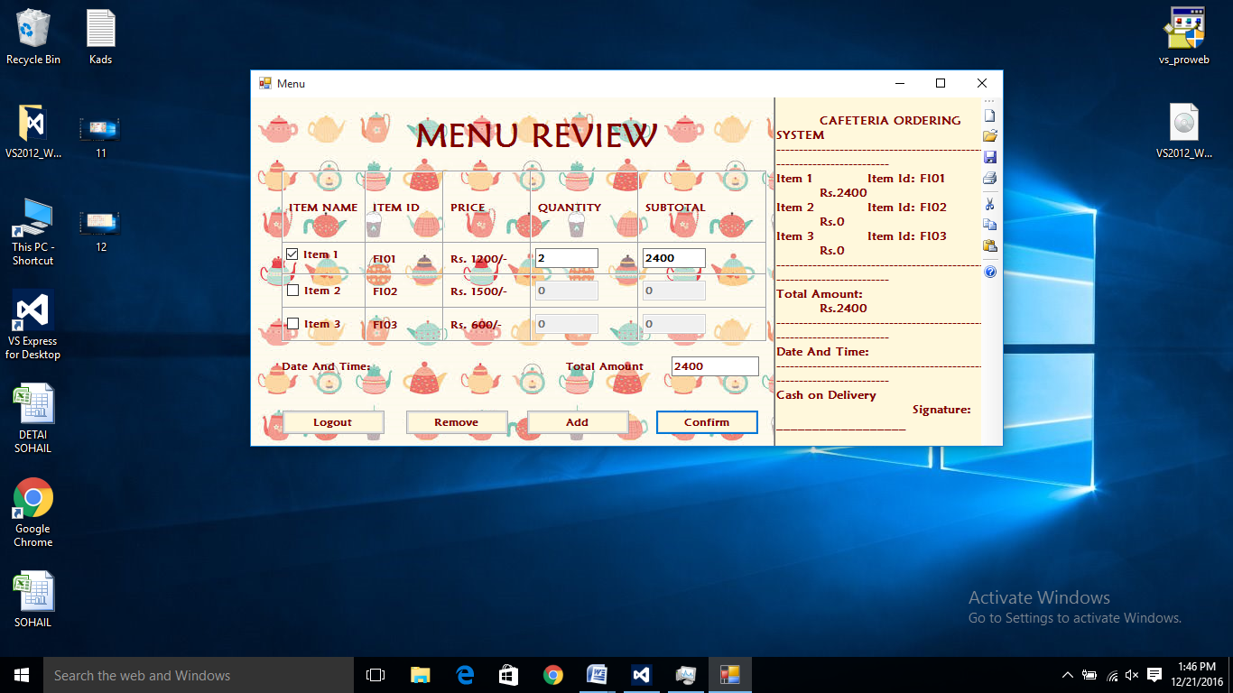

1. **Customer Receipt**

